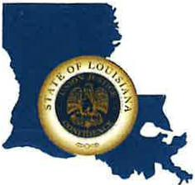 | CAPITAL AREA GROUNDWATER CONSERVATION DISTRICT
GARY I. BEARD
EXECUTIVE DIRECTOR

MEETING NOTICE
Capital Area Groundwater Conservation District Board Executive Committee Meeting

WHEN: March 8, 2023

TIME: Noon

WHERE: Capital Area Groundwater office
3535 S. Sherwood Forest Blvd.
Suite 135
Baton Rouge, LA 70816

Contact Person: Lisa Manda, (225) 293-7370

